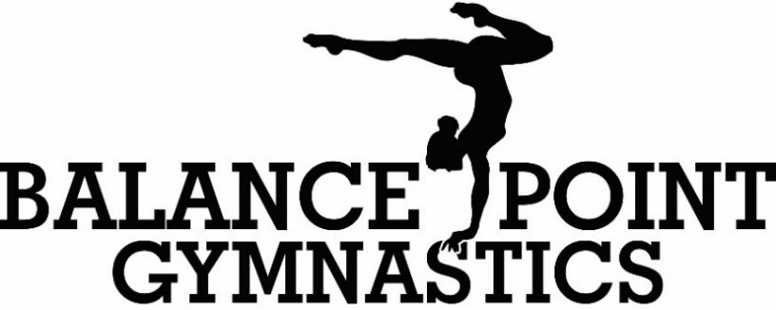
Athlete’s Name______________________ Date of Birth_______ Age___ Class_____________
Emergency Contact Name______________________ Phone #___________________________
Email Address _________________________________________________________________
- My child will continue in their current class for the school year session (August through May)
- I would like for my child to continue in the school year session; however, their current class time will not work. Please contact me with alternate class options.
- My child is new to Balance Point and I would like to enroll them in the next available class.
Thank you for choosing Balance Point, LLC! We are excited to have you and your child joining us!
Waiver of Liability, COVID-19 Acknowledgement, and Photo Release:
As the parent or legal guardian of the above listed student, I consent to their participation in programs offered by Balance Point, LLC. I acknowledge that injuries can occur during sport activities, including gymnastics. I acknowledge the risk involved, and I release Balance Point Gymnastics, its owners, and employees from all liability from any injuries suffered by my child while under the supervision of Balance Point, LLC.
As Governments try to balance health risks and economic concerns, many businesses will reopen before a coronavirus vaccine is ready. Even if employers and employees take all precautions to reduce the risk of exposing customers to the infection, illness can still occur. Businesses that attract groups or require person-to-person contact- are especially at risk. I acknowledge attending Balance Point Gymnastics Center for lessons is not mandatory and a voluntary action. I acknowledge the risks involved during the pandemic and release Balance Point Gymnastics Center, its owners, and employees from all liability in concern with COVID19 or any other illnesses.
As the parent or legal guardian of the above listed student, I am aware and consent for my child’s picture to be taken. I also acknowledge these pictures may appear on social media, newspapers and other forms of publications used by Balance Point, LLC.
Parent / Legal Guardian Signature_____________________________________Date_____________________________
_________________________________________________________________________________________________
Please understand we do NOT charge a registration fee to register for our program. To keep your child’s place in class you must pay tuition at the first of each month. Failure to pay will forfeit your child’s place to the next child on the waiting list.
Gym Reminders:
- All class tuition is due the first class session of the month.
- Athletes should wear leotards or athletic shorts with a fitted t-shirt. Also, please pull your child’s hair up out of their face before each class.
- Parents are welcome to watch all classes from the lobby. Only gymnasts and coaches are allowed in the gym during class.
- Please make sure we have your correct email address. Balance Point sends out all important information and answers all class questions by email. We will NOT send you any emails that do not relate directly to your child.

